

CharityConnect

NGO Management System

Submitted in Partial Fulfillment of Requirements for the Degree of

**Bachelor of Science (Computer Science Hons)**

By

**Kashish Sharma**

Seat No: 31011123056

Guide

**Dr. Sunita A. Yadav**



**S K Somaiya College** Somaiya Vidyavihar University Vidyavihar, Mumbai - 400 077

## 2021-24

**Somaiya Vidyavihar University**



## S K Somaiya College Certificate

This is to certify that the project report on dissertation entitled **CharityConnect (NGO Management System)**is bonafide record of the dissertation work done by **Kashish Sharma** in the year 2024-25 under the guidance of **Dr Sunita A. Yadav** Department of Information Technology and Computer Science in partial fulfillment of requirement for the Bachelor of **Computer Science Hons** degree of Somaiya Vidyavihar University.

Guide Programme Coordinator

Head of the Department Director

Date:

Place: Mumbai-77

**Somaiya Vidyavihar University**



## S K Somaiya College Certificate of Approval of Examiners

This is to certify that the project report on dissertation entitled **CharityConnect (NGO Mangement System)**is bonafide record of the dissertation work done by **Kashish Sharma** in partial fulfillment of requirement for the Bachelor of Science degree in **Computer Science Hons** of Somaiya Vidyavihar University.

External Examiner /Expert Internal Examiner/ Guide

Date:

Place: Mumbai-77



**Somaiya Vidyavihar University**

## S K Somaiya College

#### DECLARATION

I declare that this written report submission represents the work done based on my and / or others’ ideas with adequately cited and referenced the original source. I also declare that I have adhered to all principles of academic honesty and integrity as I have not misinterpreted or fabricated or falsified any idea/data/fact/source/original work/ matter in my submission.

I understand that any violation of the above will be cause for disciplinary action by the college and may evoke the penal action from the sources which have not been properly cited or from whom proper permission is not sought.

**Signature of the Student**

Kashish Rajkumar Sharma

**Name of the Student**

31011123056

**Seat No.**

**Date:**

**Place: Mumbai-77**

# Acknowledgement



I am profoundly grateful to S.K Somaiya College for providing me with an excellent academic environment and the necessary resources to pursue my studies and conduct my final project. This institution has been a place of learning and also a venue where I could push myself beyond my comfort zone.

I extend my heartfelt thanks to the Director, CA. Monica Lodha, for her unwavering support and encouragement.

My gratitude goes to Dr. Swati Maurya, Head of the Department of Information Technology & Computer Science for her invaluable guidance and encouragement. I would also like to extend my thanks to Ms. Minal Dive, Coordinator of the Department whose assistance and support played a crucial role in the successful completion of my project

A special note of thanks to my project guide, Dr Sunita A. Yadav whose expertise and understanding were instrumental in shaping the direction and execution of this project. Her patience and commitment to excellence have greatly inspired and motivated me.

Lastly, I cannot forget the incredible support of my parents and friends, whose encouragement and faith in me have been my pillars of strength. Their constant support and optimism have helped me navigate through challenges and stay focused on my goals.



# Abstract

The aim of the NGO Management System is to automate the existing manual processes of volunteer, event, and donation management with the help of computer-based software. This system ensures that valuable data and information are securely stored for long-term access, making management efficient and error-free. The necessary software and hardware are readily available, making the system easy to use and implement.

The **NGO Management System** enhances transparency, reliability, and speed in handling volunteer records, event organization, and donation tracking. By automating these processes, NGOs can focus on their core activities rather than manual record-keeping, ensuring better resource utilization and effective decision-making. The system eliminates redundant entries, providing a streamlined approach to NGO operations while maintaining accuracy and accessibility.

***Keywords: Automate, Easy Access, Handling, Secure, Reliable, Fast Management System, Redundant Entries, Organization, Valuable, Data/Information***

**Index**



|  |  |  |  |  |  |
| --- | --- | --- | --- | --- | --- |
| **List of Tables** | | | | | Page no |
| **1** | **Introduction** | | | | 9 |
|  | 1.1 | | Introduction and background of the project | | 9 |
|  | 1.2 | | Objectives of project and Problem Statement | | 11 |
|  | 1.3 | | Scope, Advantages, and applicability of project | | 12 |
| **2** | **Survey of Technologies** | | | | 14 |
|  | 2.1 | | Existing technologies | | 14 |
|  | 2.2 | | Technology implemented for the project | | 16 |
| **3** | **Requirement and Analysis** | | | | 20 |
|  | 3.1 | | Problem Statement with major modules | | 20 |
|  | 3.2 | | Feasibility Study | | 23 |
|  | 3.3 | | Software Requirement Specification | | 24 |
|  |  | | 3.3.1 | Functional Requirements | 24 |
|  |  | | 3.2.2 | Non-functional Requirements | 24 |
|  | 3.4 | System software and Hardware requirements | | | 25 |
|  | 3.5 | SDLC model | | | 26 |
|  |  | 3.5..1 | | Waterfall model |  |
|  | 3.6 | Project Scheduling | | | 28 |
|  |  | 3.6.1 | | GANTT Chart |  |
| **4** | **System Design** | | | | 29 |
|  | 4.1 | Block Diagram | | | 29 |
|  | 4.2 | Use case Diagram | | | 30 |

|  |  |  |  |  |
| --- | --- | --- | --- | --- |
|  | 4.3 | Sequence Diagram | | 31 |
|  | 4.4 | ER Diagram | | 32 |
|  | 4.5 | Project system screens | | 33 |
| **5** | **Implementation and Testing** | | | 41 |
|  | 5.1 | | Implementation details | 41 |
|  | 5.2 | | Testing Approaches | 52 |
|  | 5.3 | | Test Cases and Test Results | 53 |
| **6** | **Results and Discussion** | | | 55 |
| **7** | **Conclusion and Future work** | | | 57 |
| **References** | | | | 59 |



**List of Figures**



|  |  |  |
| --- | --- | --- |
| **Fig No.** | **Name of the Figure** | **Page No.** |
| 3.5.1 | Waterfall Model |  |
| 3.6.1 | GANTT Chart | 28 |
| 4.1.1 | Block Diagram | 29 |
| 4.2.1 | Use case Diagram | 30 |
| 4.3.1 | Sequence Diagram | 31 |
| 4.4.1 | ER Diagram | 32 |

**Chapter 1 Introduction**

*This chapter includes the Introduction ,background, objectives, problem statement , scope and organization of report.*

## Introduction and background of the project

**Introduction**

* + - “The **NGO Management System** was developed to overcome the challenges of manual record-keeping and management in non-governmental organizations. This software aims to eliminate inefficiencies and, in some cases, reduce errors encountered in traditional systems. It is specifically designed to meet the operational needs of NGOs, ensuring smooth and efficient handling of volunteers, events, and donations. The system minimizes data entry errors and provides validation to prevent incorrect inputs. No formal technical knowledge is required for users to operate the NGO Management System, making it accessible to all.
    - With its user-friendly interface, the system ensures secure, reliable, and fast management of NGO activities. By automating volunteer registrations, task assignments, event planning, and donation tracking, the system enables organizations to focus on their core mission rather than administrative tasks. This ultimately leads to better resource utilization, enhanced transparency, and improved decision-making.

* + - Every NGO, regardless of size, faces challenges in managing volunteer data, event coordination, and financial records. The **NGO Management System** is designed to support strategic planning and ensure that organizations have the necessary information for future goals. It provides a centralized platform for storing and retrieving essential data, reducing redundancy and improving efficiency.
    - Furthermore, the system allows NGOs to manage their operations effectively by streamlining processes such as event scheduling, volunteer tracking, and financial reporting. With automated notifications, real-time updates, and detailed reports, NGOs can operate more efficiently, ensuring a greater impact on their social causes.

## Objectives of Project and problem statement

**Objectives:**

* + - To provide Efficient volunteer management system for NGOs
    - To streamline **event organization** by automating the scheduling and management process.
    - To increase staff productivity by automating routine tasks such as volunteer registration, task assignments, and donation tracking.
    - To provide **secure storage for volunteer, event, and donation records** to ensure data integrity and easy access.

### Problem Statement:

Are you struggling with the time-consuming and error-prone manual processes used in your NGO? Do you face challenges in managing volunteer records, event planning, donation tracking, and overall organizational operations?

If so, then you understand the difficulties NGOs encounter when relying on outdated and inefficient management systems. These challenges can lead to mismanagement of resources, lack of transparency, and inefficiencies in executing social initiatives. Without a structured system, NGOs may struggle with volunteer coordination, event scheduling, and financial accountability, which can impact their overall effectiveness and credibility.

## Scope, Advantages, and applicability of project

**Scope:**

* + - • The system can manage volunteer registration and track their skills, availability, and contributions.
    - • The system can schedule and manage NGO events, send event notifications, and allow volunteers to sign up for events.
    - • The system provides secure storage for volunteer, event, and donation records, ensuring data protection and preventing unauthorized access.
    - • The NGO Management System can be customized to meet the specific needs of different NGOs, regardless of their size and operational structure.
    - • The project aims to reduce manual work by automating volunteer management, event coordination, and donation tracking.
    - • The system contains all necessary information about volunteers, events, and financial contributions, making record-keeping easier and more efficient.
    - • It keeps track of every detail regarding volunteers, event participation, tasks, and donation history, ensuring transparency and accountability.

**Advantages:**

* + - Efficient Volunteer and Event Management: Streamlining volunteer registration, task assignments, and event scheduling helps NGOs operate smoothly and utilize resources effectively.
    - Improved Organizational Efficiency: Automating administrative tasks reduces manual workload, allowing NGOs to focus on their core mission rather than paperwork.
    - Enhanced Transparency and Accountability: The system securely tracks donations, volunteer contributions, and event details, ensuring financial transparency and accountability.
    - Remote Access and Online Coordination: Volunteers and donors can access the system remotely, sign up for events, and contribute online, making NGO activities more accessible.
    - Scalability and Growth: The system is adaptable to the evolving needs of NGOs, supporting expansion, new projects, and increased volunteer participation.

# Chapter 2 Survey of Technologies

*This chapter consists of Existing technologies and the technologies which were implemented in this project and why.*

## Existing technologies

* + - C# (.NET Framework): C# is used for developing the NGO Management System with Windows Forms for a desktop-based application. It provides a powerful and structured approach to managing NGO operations
    - Microsoft SQL Server: The system utilizes SQL Server as its database management system, ensuring efficient storage and retrieval of volunteer records, event details, and donation transactions.
    - Windows Forms (WinForms): A GUI framework in .NET used to create an intuitive and user-friendly interface for NGO staff and volunteers.
    - Google Maps API: Integrated to provide real-time event location tracking and display maps for event management.
    - ASP.NET (for future web-based expansion): If extended to a web-based platform, ASP.NET could be used to develop a web-based NGO Management System for remote access and enhanced functionality.
    - Visual Studio: The system is developed using Microsoft Visual Studio, providing a robust Integrated Development Environment (IDE) for coding, debugging, and testing.

## Technology implemented for the project

### Frontend Technologies:

Windows Forms (WinForms): Used to create the graphical user interface (GUI) for the NGO Management System, providing an intuitive and interactive user experience.

C# (C-Sharp): The primary programming language for handling user interactions, form validation, and UI logic in the Windows application.

GDI+ (Graphics Device Interface Plus): Used for custom UI design, rendering visuals, and enhancing the application's appearance with modern styling.

Google Maps API: Integrated into the system for event location visualization and navigation assistance.

### Backend and Database:

C# (.NET Framework): Handles backend logic, user authentication, and system operations efficiently.

Microsoft SQL Server: A relational database management system (RDBMS) used for storing and managing volunteer records, event details, donation transactions, and reports.

### API :

Google Maps API: Enables event location tracking and geolocation features for better event coordination.

Third-Party APIs (Future Scope): Can be integrated for additional functionalities like payment gateways (PayPal, Stripe) for donation processing or email/SMS notifications (Twilio, SendGrid) for event reminders.

**Why These Technologies Were Chosen Over Others**

## Microsoft Visual Studio (VS Code Alternative):

* Optimized for .NET and C#: Microsoft Visual Studio is specifically designed for C# and .NET applications, making it the best choice for developing a Windows-based NGO Management System.
* Drag-and-Drop UI Design: Unlike VS Code, Visual Studio provides a Windows Forms Designer, allowing easy drag-and-drop UI creation, reducing manual UI coding.
* Advanced Debugging Tools: Includes breakpoints, watch windows, and real-time error detection, making debugging more efficient compared to VS Code.
* Integrated Git Support: Built-in version control simplifies code management, allowing seamless collaboration.
* Rich Extensions & Active Community: Offers a vast library of extensions for added functionality and has strong community support for troubleshooting and learning.

## Microsoft SQL Server (MySQL/XAMPP Alternative) :

* Better Security & Performance: Provides built-in encryption, user authentication, and high-speed performance, making it more secure than MySQL.
* Optimized for .NET Applications: Works seamlessly with C# and Visual Studio, ensuring faster queries and data retrieval.
* Supports Large-Scale Databases: Handles large amounts of NGO data efficiently, unlike MySQL, which is better suited for small-scale applications.
* Graphical Query Management: SQL Server Management Studio (SSMS) offers an interactive UI for database management, making it easier to work with than MySQL’s command-line interface.

## C# and .NET (PHP/JavaScript Alternative) :

* Structured & Object-Oriented: Unlike PHP, C# is a strongly typed, object-oriented language, making the application more maintainable and scalable.
* Best for Windows Applications: Since the NGO Management System is Windows-based, using C# ensures better performance and native support.
* Secure & Reliable: .NET provides built-in security features like role-based authentication, making it more secure than PHP.
* Efficient Data Handling: Unlike JavaScript, C# can process large database queries and operations efficiently using Entity Framework.

# Chapter 3 Requirement and Analysis

*This chapter consists of problem statement with major modules and various functional and non functional requirements. It includes the Software development lifecycle model which is used in this project and project scheduling. It also elaborates about the stakeholders of the project.*

* 1. **Problem Statement with major modules**

**Problem Statement*:***

Are you tired struggling with managing volunteers, tracking donations, and organizing events manually? Do you face challenges in keeping accurate records, assigning tasks efficiently, and ensuring smooth communication within your NGO?

Manual systems often lead to errors, delays, and inefficiencies, making it difficult to coordinate volunteers, manage donor contributions, and track event progress. These challenges can slow down operations and affect the overall impact of an NGO's efforts.

A modern NGO Management System is essential for streamlining operations, reducing errors, and enhancing productivity. By implementing an automated, secure, and user-friendly system, NGOs can focus more on their mission rather than administrative tasks. It’s time to adopt a centralized digital platform that simplifies management, improves transparency, and ensures the smooth functioning of your NGO.

## MAJOR MODULES

**User Management Module:**

* + - User Registration & Authentication: Secure login system for Admins, Volunteers, Donors, and Event Coordinators.
    - Role-Based Access: Restrict functionalities based on user roles.
    - Profile Management: Users can update personal details and preferences.

**Volunteer Management Module:**

* + - Volunteer Registration: Collect skills, availability, and interests.
    - Task Assignment & Tracking: Assign tasks and monitor progress.
    - Performance Reports: Track volunteer contributions and engagement.

**Donation Management:**

* + - Donation Tracking: Record monetary & in-kind donations.
    - Online Payments: Integrate PayPal, Stripe, or bank transfers.
    - Donor Reports & Engagement: Generate insights and send appreciation emails.

**Event Management:**

* + - Event Creation & Registration: Manage fundraisers and volunteer events.
    - Google Maps Integration: Display event locations.
    - Notifications & Reminders: Send updates to attendees.

## STAKEHOLDERS

**End Users :**

* + - NGO Administrators: Oversee system operations, manage users, configure settings, and generate reports.
    - Volunteers: Register, receive task assignments, track progress, and update availability.
    - Donors: Contribute funds or resources, track donation history, and receive acknowledgments.
    - Event Coordinators: Plan and manage fundraising or volunteer events, track attendance, and send updates.
    - Beneficiaries: Receive NGO services and assistance, interacting with the system where applicable.

## Development Team :

* + - Project Manager: Oversees development, coordinates tasks, and ensures project goals are met on time and within budget.
    - Developers: Design, implement, test, and maintain the system, handling both frontend and backend functionalities.
    - UI/UX Designers: Create an intuitive and visually appealing interface for users, improving overall experience.
    - Quality Assurance (QA) Team: Conduct manual and automated testing to ensure system reliability and functionality.
    - Database Administrators (DBAs): Manage database performance, ensure data integrity, and handle backups for secure storage.

## Feasibility Study

#### TECHNICAL FEASIBILITY

* + - System Requirements: Assess functionality, performance, security, and scalability to ensure compatibility with available technology and resources.
    - Technology Stack: Evaluate programming languages, databases, frameworks, and tools based on compatibility, support, and ease of use.
    - Infrastructure: Identify hardware and software needs, ensuring scalability, reliability, and cost-effectiveness.
    - Integration: Ensure seamless connectivity with existing systems (EHRs, accounting software) and external services (payment gateways, telemedicine).
    - Security: Implement measures to protect patient data, comply with regulations (e.g., HIPAA), and prevent unauthorized access or cyber threats.
    - Performance: Optimize speed and responsiveness, especially for high-volume data processing and peak usage times.

## Software Requirement Specification

**Functional Requirements**

* + - Use Cases: Describe the primary use cases of the system, including scenarios, actors, and interactions.
    - Functional Requirements: List and describe each functional requirement of the system, specifying inputs, outputs, and behavior.
    - User Stories: Present user stories that illustrate how users will interact with the system to achieve specific tasks.

## Non-Functional Requirements

* + - Performance Requirements: Define performance metrics such as response time, throughput, and scalability.
    - Security Requirements: Specify security measures to protect sensitive data, prevent unauthorized access, and comply with regulations.
    - Reliability Requirements: Outline reliability goals, including uptime, fault tolerance, and disaster recovery.
    - Usability Requirements: Describe usability criteria and guidelines to ensure a user-friendly interface and intuitive interaction.
    - Compatibility Requirements: Specify compatibility with hardware, software, browsers, and operating systems.
    - Documentation Requirements: Detail documentation needs for users, administrators, developers, and support staff.

## System software and Hardware requirements Software Requirements: -

#### 1. Integrated Development Environment (IDE)

* **Visual Studio** – Used for coding, debugging, and designing the Windows Forms UI.
* **SQL Server Management Studio (SSMS)** – Manages the Microsoft SQL Server database.

**2. Programming Languages & Frameworks**

* **C# (Windows Forms)** – Used for building the application's logic and user interface.
* **SQL (Structured Query Language)** – Used for managing the database and executing queries.

**3. Database Management System**

* **Microsoft SQL Server** – A relational database system used to store and manage NGO-related data.

**4. UI Development Tools**

* **Windows Forms Designer** – Used for UI design within Visual Studio.
* **DataGridView Control** – Enables tabular data display and management.

**5. APIs & Integrations (Planned Enhancements)**

* **Google Maps API** – For event location mapping (future integration).
* **Payment Gateway API** – For online donations (future integration).

**6. Security & Authentication**

* **.NET Authentication System** – For secure user login and role management.
* **Input Validation & Error Handling Mechanisms** – Ensures security and data integrity.

**7. Performance & Scalability Tools**

* **Optimized Database Queries** – Enhances speed and efficiency.
  + - **Modular Code Structure** – Supports future enhancements and scalability.

## Hardware Requirements:

* + - Processor (CPU)
    - Intel or AMD processor with a minimum 1 GHz clock speed for smooth application performance.
    - Memory (RAM)
    - At least 2 GB RAM to efficiently handle database operations and user interactions.
    - Storage
    - At least 500 MB of free disk space for installing Visual Studio, SQL Server, and project files.
    - Graphics Processing Unit (GPU)
    - Not required for standard application use, as the system does not involve graphics-intensive tasks.
    - Optional GPU for advanced visualization or potential future enhancements.
    - Operating System (OS)
    - Windows OS (Recommended) – Ensures compatibility with Visual Studio and SQL Server.

## SDLC model

The Waterfall model outlines a sequential approach to software development, where each phase progresses in a linear manner, ensuring that one phase is completed before moving to the next. For the " CharityConnect (NGO Management System)" project, this model unfolds as follows:

* + - **Planning Phase:**

In this phase, project objectives, scope, requirements, and constraints are defined.

Key activities include project initiation, feasibility analysis, and stakeholder consultation to establish project goals and constraints.

* + - **Analysis Phase:**

Requirements are gathered and documented. Stakeholders, including NGO staff, volunteers, and administrators, provide input to ensure the system aligns with their needs. Functional requirements such as user registration, task assignments, event scheduling, and donation tracking are defined. Non-functional requirements like security, scalability, and performance are also considered.

* + - **Design Phase:**

System architecture, is designed based on the gathered requirements. This includes defining the database schema in Microsoft SQL Server, designing the user interface in Windows Forms, and structuring the backend using C#. The design ensures modularity, making it easier to maintain and scale.

* + - **Implementation Phase:**

The development team writes the actual code, implementing the features defined in the design phase. Key functionalities include:

Volunteer Management Module: Registration, task assignment, and progress tracking.

Event Management Module: Event scheduling, Google Maps integration for location tracking, and attendance management.

Donations Module: Secure transaction handling, donor management, and reporting.

User Authentication & Authorization: Role-based access control for different user types.

* + - **Testing Phase:**

The system undergoes rigorous testing to ensure reliability, security, and performance. Unit testing verifies individual components like volunteer registration, event scheduling, and donation tracking, while integration testing ensures seamless module interaction. User Acceptance Testing (UAT) is conducted with NGO staff and volunteers to validate real-world functionality. Any identified bugs or inconsistencies are fixed before deployment.

* + - **Deployment Phase:**

After successful testing, the system is deployed for NGO operations. This includes database setup in Microsoft SQL Server, user role configuration, and Google Maps integration for event locations. The system is installed on NGO computers or hosted on a server for accessibility. Staff and volunteers are trained, and initial monitoring ensures smooth operation with quick issue resolution.

* + - **Maintenance Phase:**

Post-deployment, regular updates improve functionality, fix bugs, and enhance security. Performance optimizations ensure fast response times, and user feedback helps refine workflows. Security patches and upgrades are applied periodically to protect donor and volunteer data, keeping the system efficient, secure, and adaptable to the NGO’s evolving.

## Project Scheduling

#### GANTT CHART

Gantt chart provides an overview of the NGO Management System project, ensuring efficient task management, from planning to deployment and maintenance.

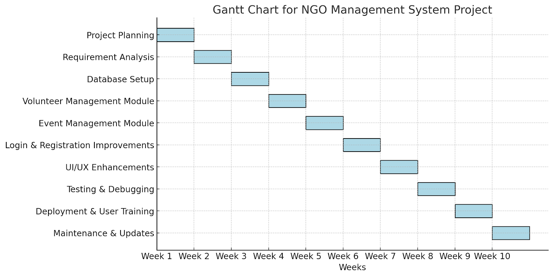

Fig 3.6.1

# Chapter 4 System Design

*This chapter presents the various diagrams created and User interface screens.*

## Block Diagram

This block diagram provides a simplified view of the various components involved in managing an NGO Management System and how they interact with each other to ensure efficient operations, volunteer coordination, event management, and donation processing

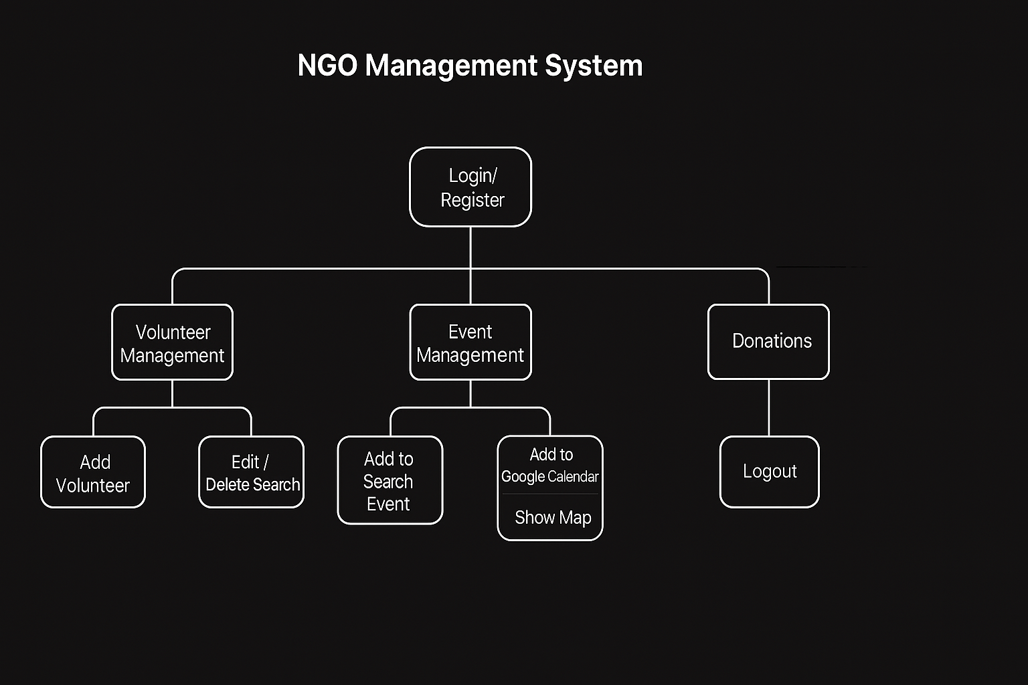

Fig 4.1.1

## Use Case Diagram

This use case diagram for the NGO Management System provides a high-level overview of the interactions between users and the system, highlighting key functionalities and features for efficient NGO operations

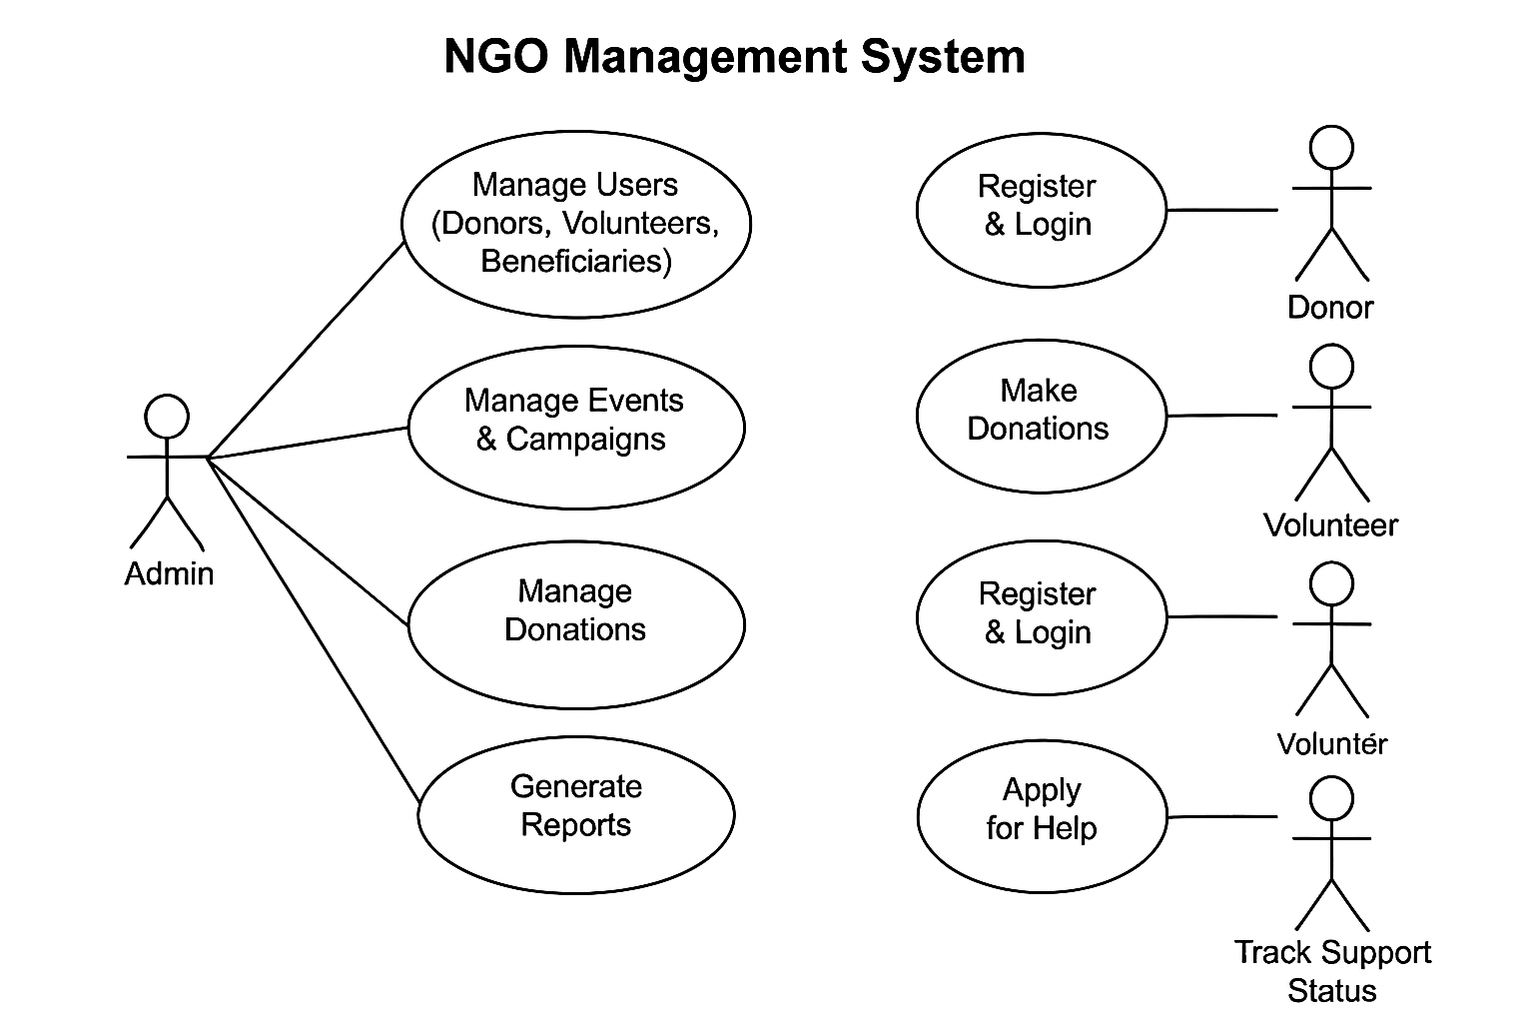

Fig 4.2.1

## Sequence Diagram

This sequence diagram provides interactions between the User (Donor/Volunteer/Admin), Login System, Database, Event Management Module, Donation Module, and UPI Payment Gateway in the NGO Management System, showing the flow of messages and actions over time.

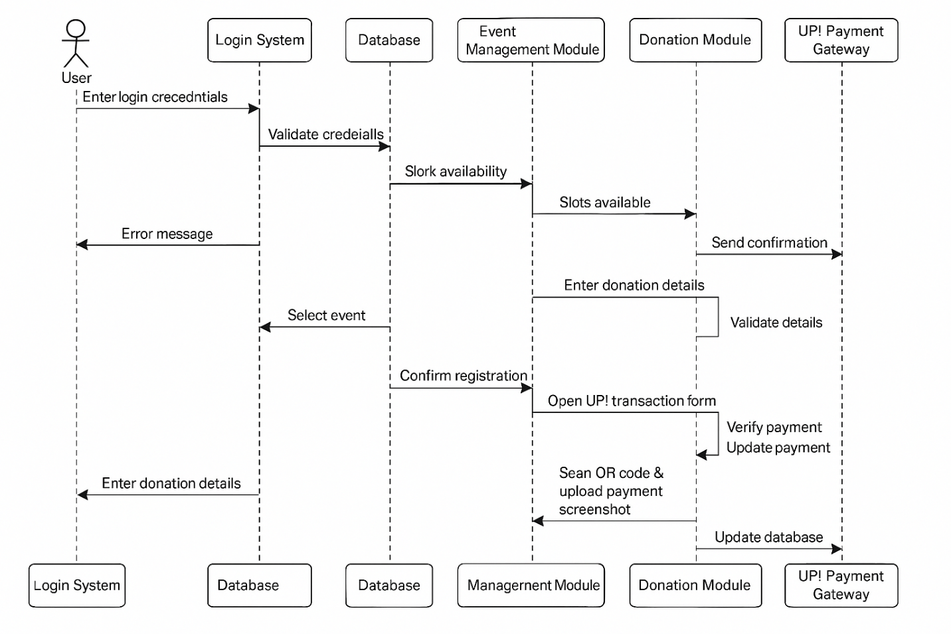

Fig 4.3.1

## Er Diagram

This ER diagram provides a visual representation of the entities, relationships, and attributes in a NGO management system, helping to understand the structure of the database and how different components of the system are connected.

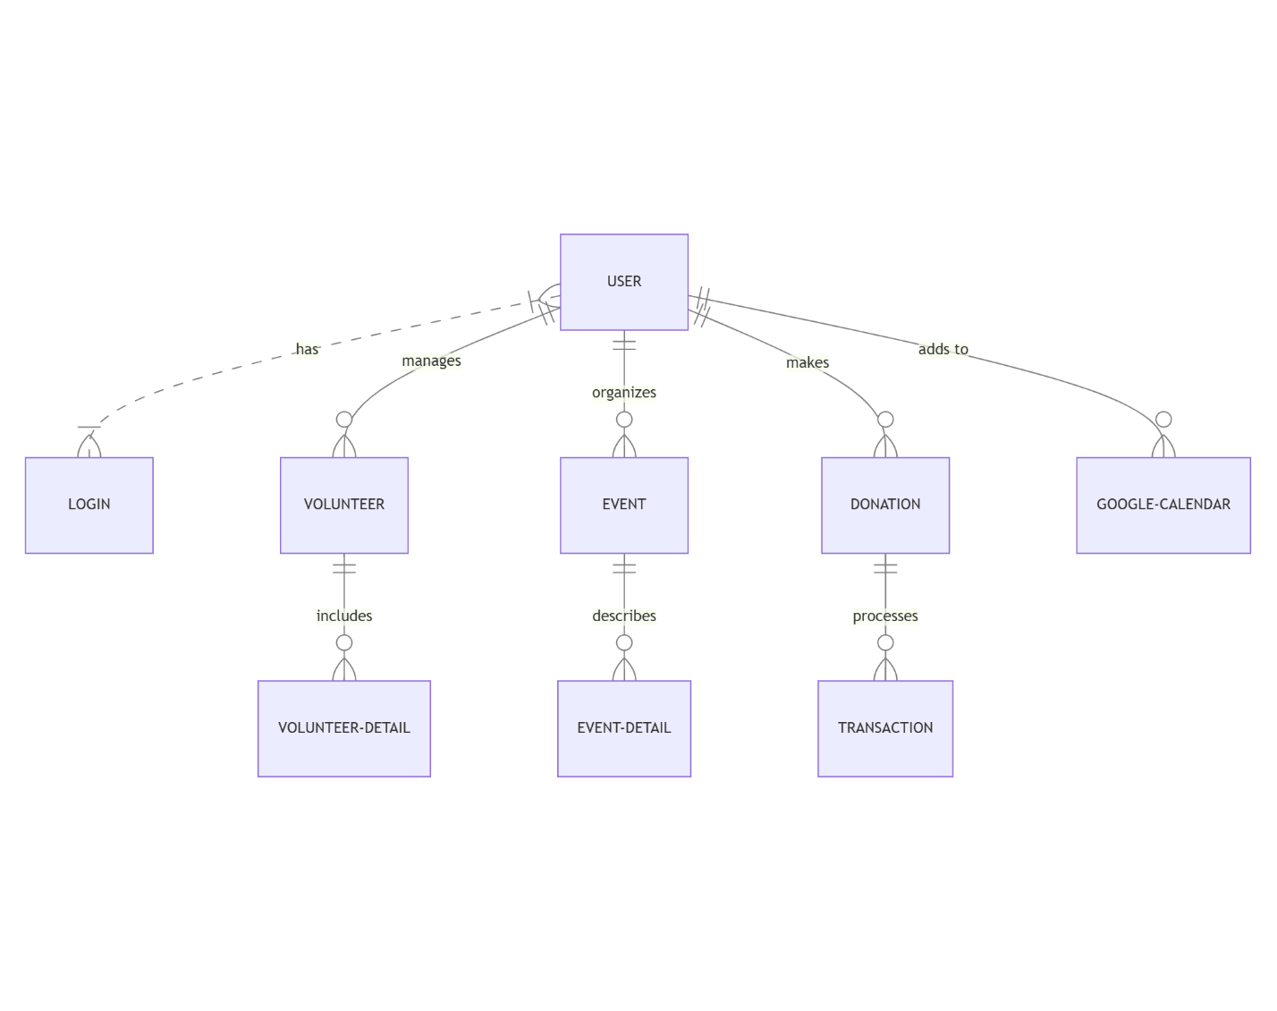

Fig 4.4.1

## Project system screens

1. **Login Page**

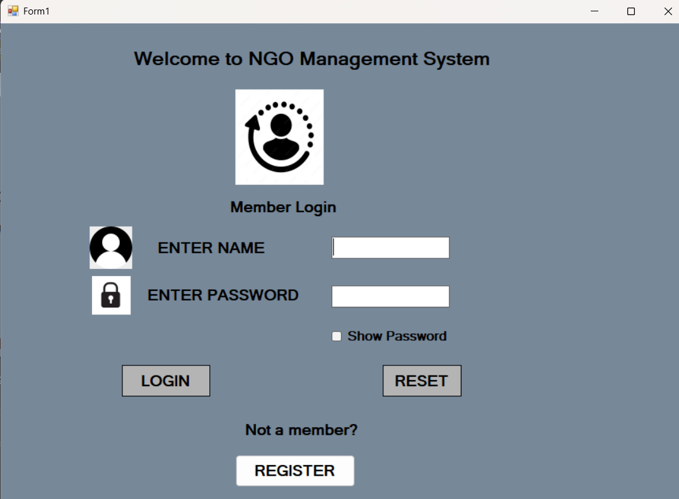

1. 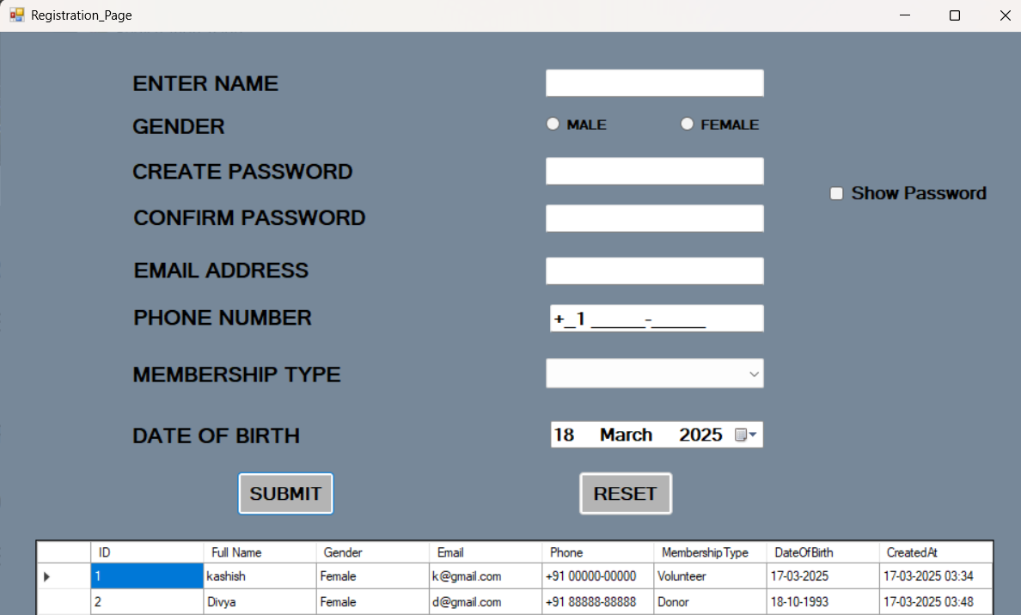**Registration Page**
2. **Main Page**

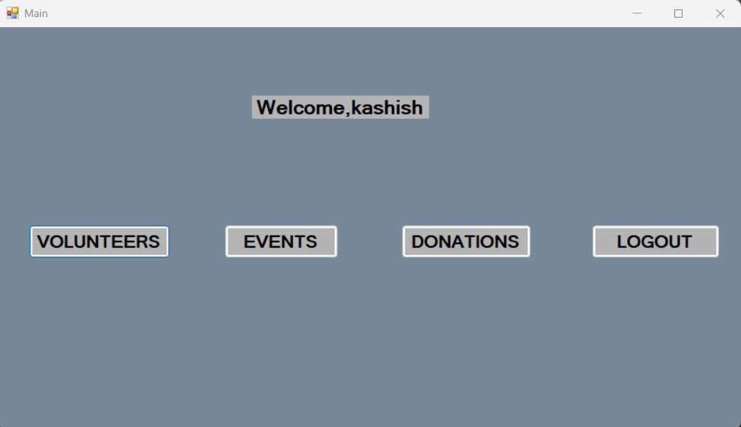

1. **Volunteer Page**

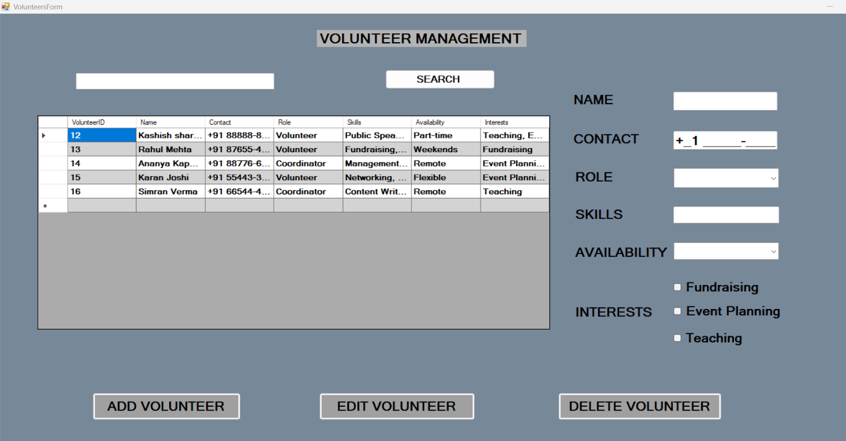

1. **Event page**

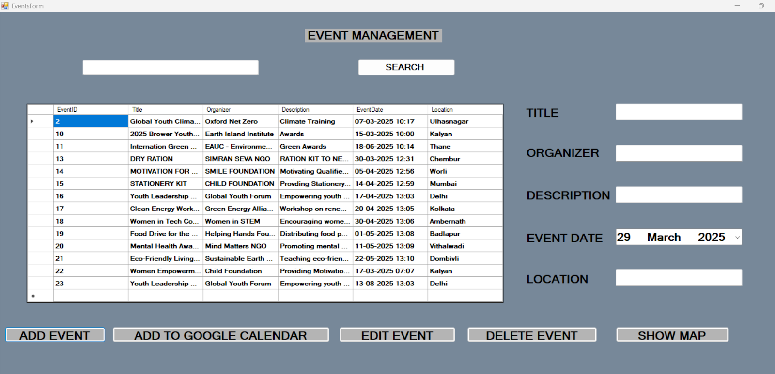

1. **Donations Page**

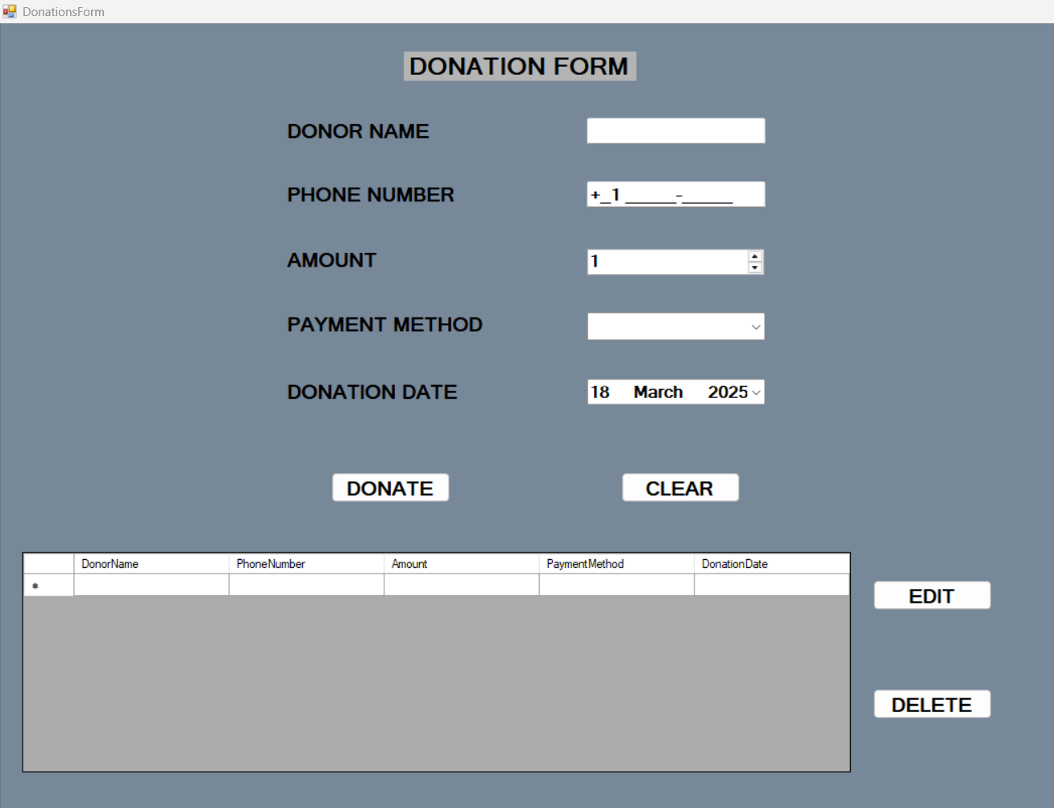

**7. UPI Transaction Page**

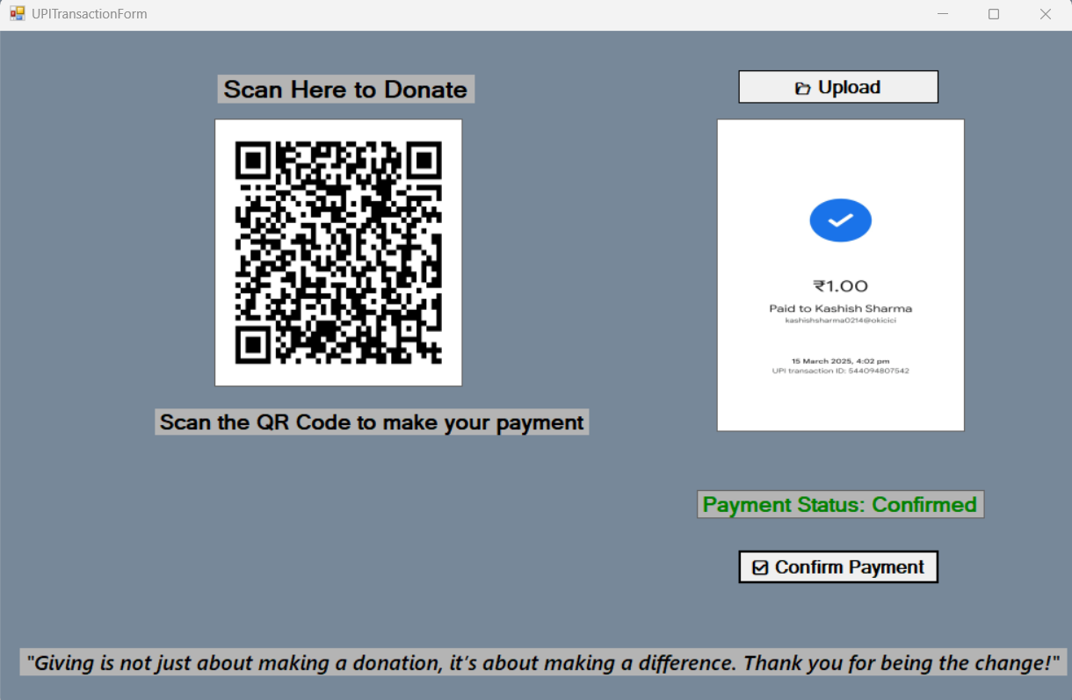

**8. Database Management System**

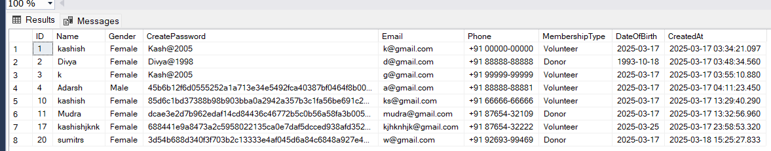

**9. Database of Volunteers**

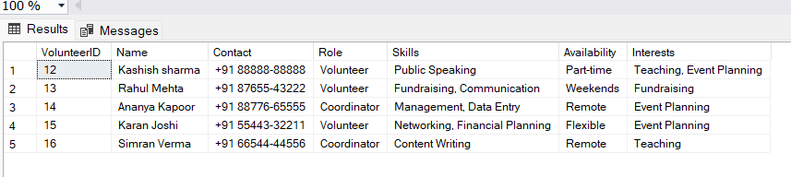

**10. Database of Events**

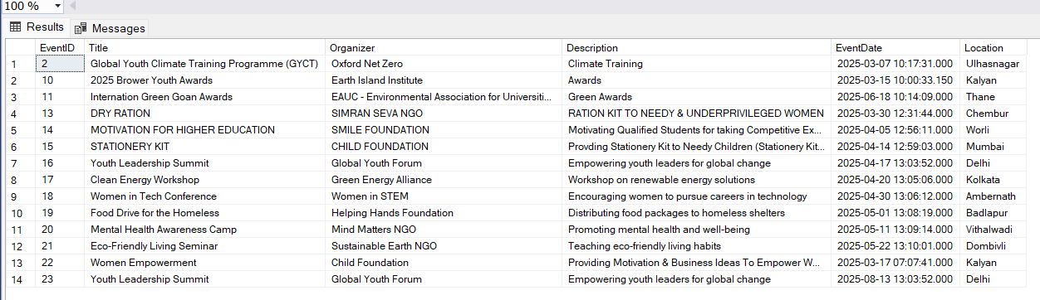

**11. Database of Donations**

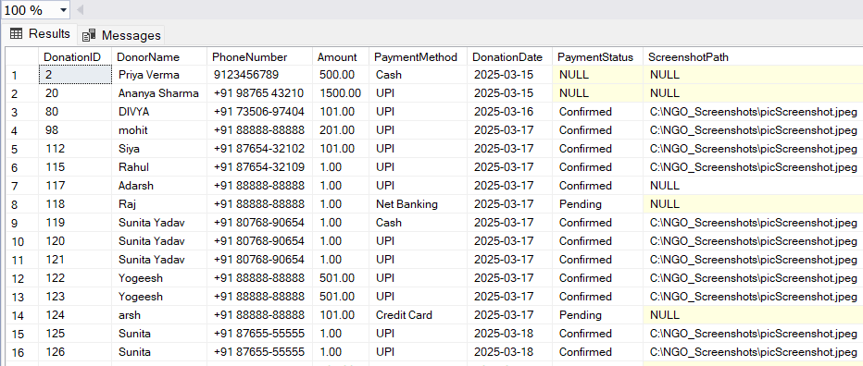



# Chapter 5 Implementation and Testing

*This chapter presents the implementation of project and various test cases and scenarios used to make the app working and safe*

## Implementation Details

#### MAIN PAGE:

Once logged in, users are greeted with a personalized welcome message displaying their name.

The dashboard provides four main navigation buttons:

Volunteers: Accesses the volunteer management module.

Events: Opens the event management section.

Donations: Directs users to the donation management module.

Logout: Ends the session and returns the user to the login screen.

#### LOGIN PAGE:

• The homepage welcomes users with the text "Welcome to NGO Management System."

• It features a Member Login section where users can enter their username and password.

Icons are used alongside input fields for a visually structured layout.

• A "Show Password" checkbox allows users to view their entered password for convenience.

• Three interactive buttons:

Login: Authenticates users and redirects them to the main dashboard upon successful login.

Reset: Clears the input fields.

Register: Allows new users to sign up.

#### REGISTRATION PAGE:

User registration with fields: Name, Gender, Password, Email, Phone Number, Membership Type,

and Date of Birth.

Password confirmation and visibility toggle.

Membership type selection.

Date of birth selection using a dropdown for day, month, and year.

Data is stored in a SQL Server database.

The Submit button inserts the data into the database.

The Reset button clears all input fields.

A DataGridView displays the registered users with columns for ID, Full Name, Gender, Email, Phone,

Membership Type, Date of Birth, and CreatedAt timestamp.

CODE OF LOGIN PAGE

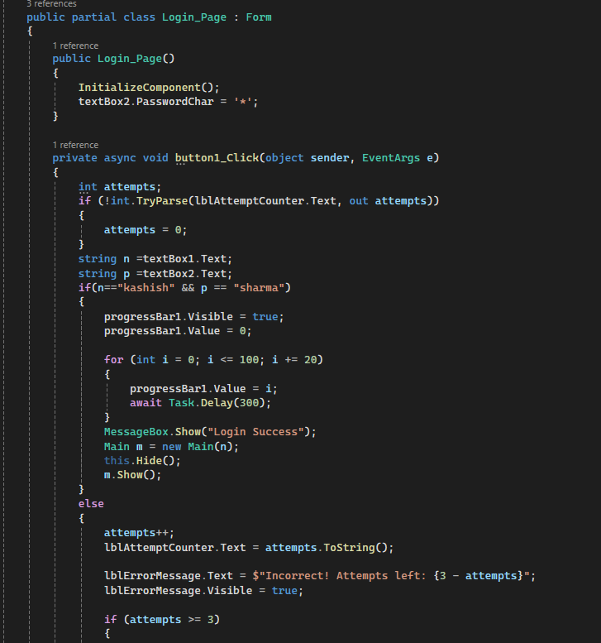

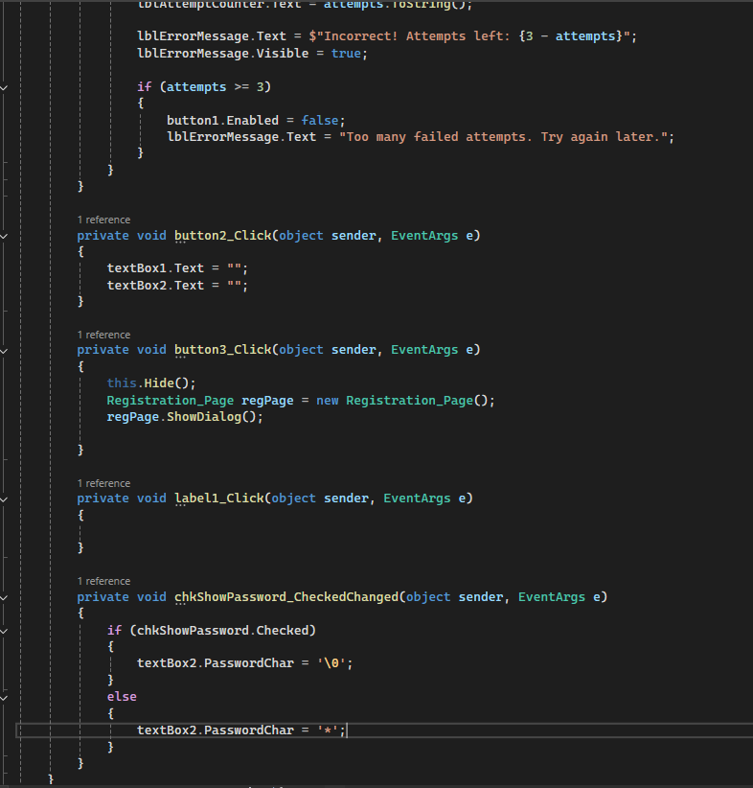

CODE OF REGISTRATION PAGE:

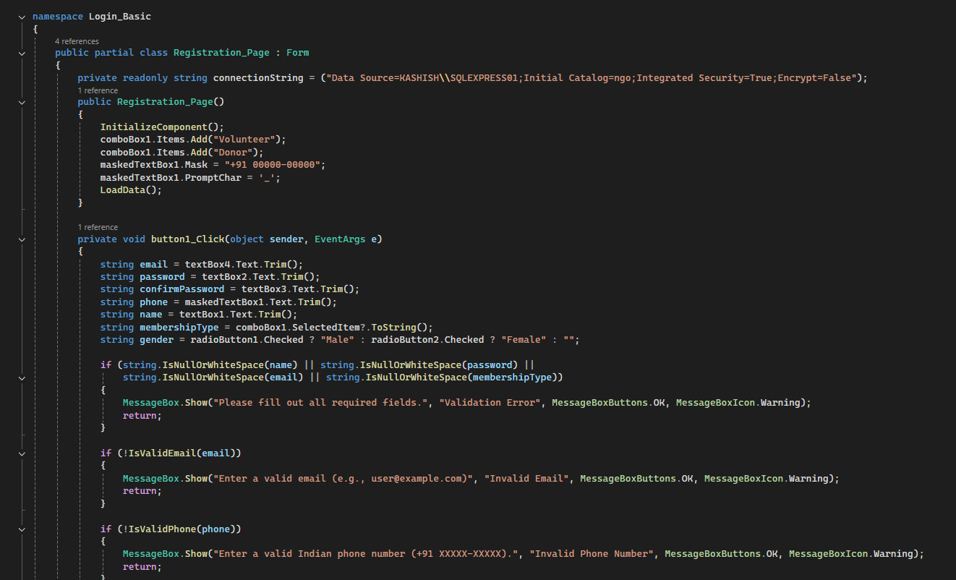

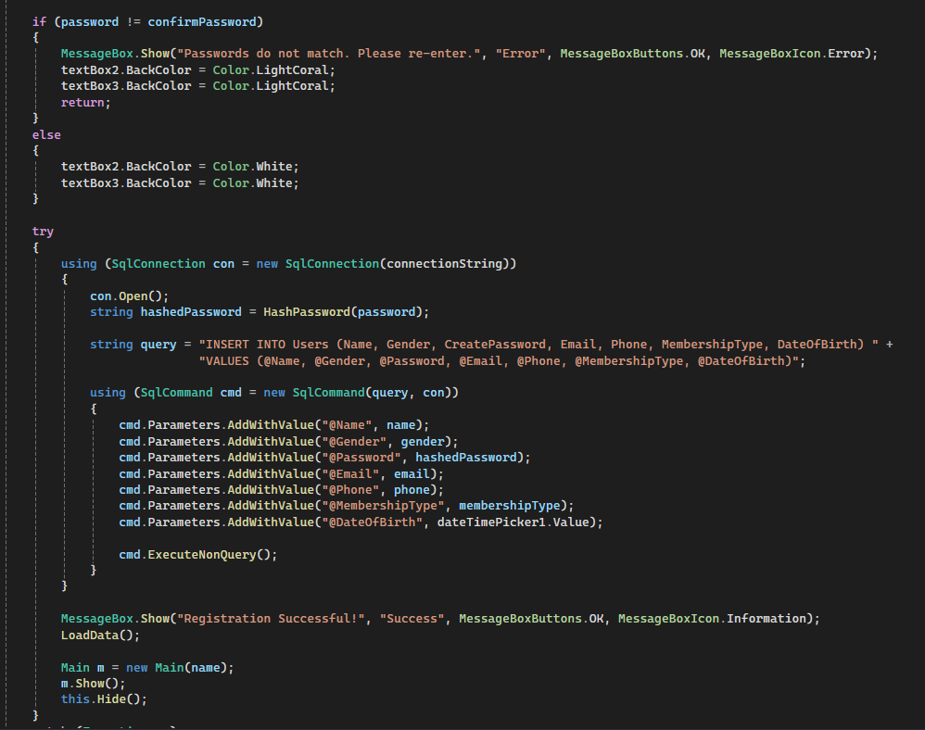

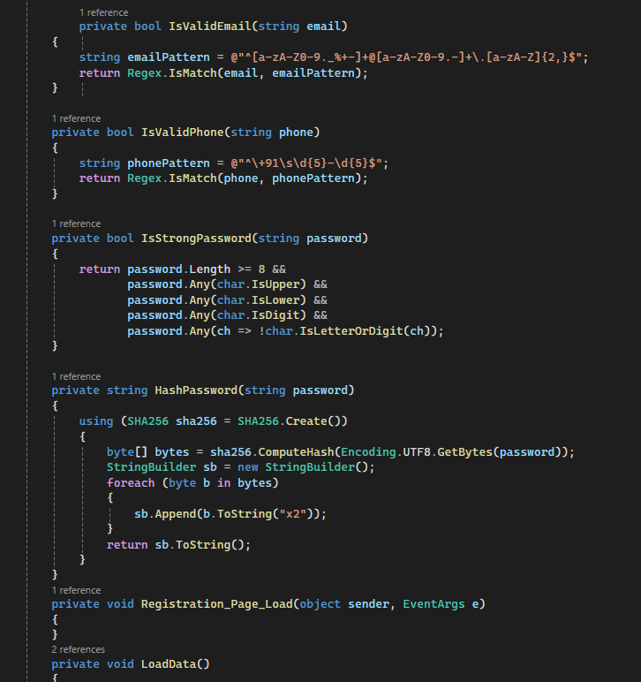

CODE OF VOLUNTEER PAGE:

**Department of Information Technology & Computer Science 2021-24 Batch** Page 42

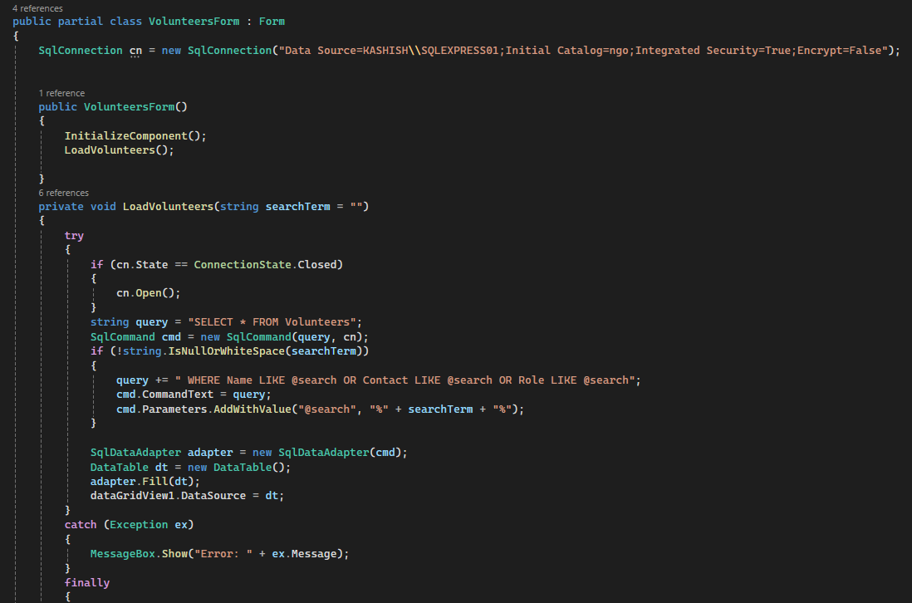

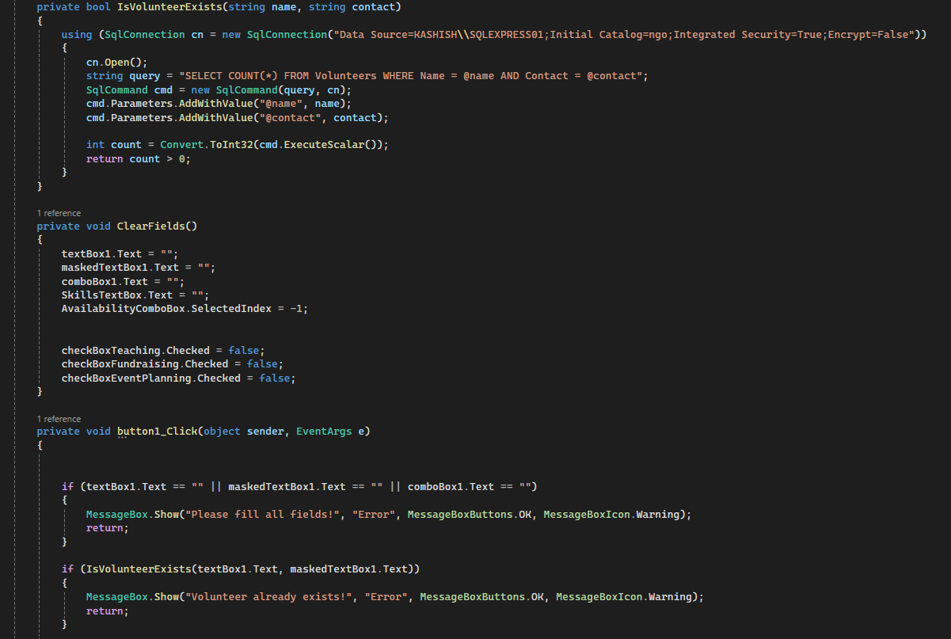

CODE OF EVENT PAGE:

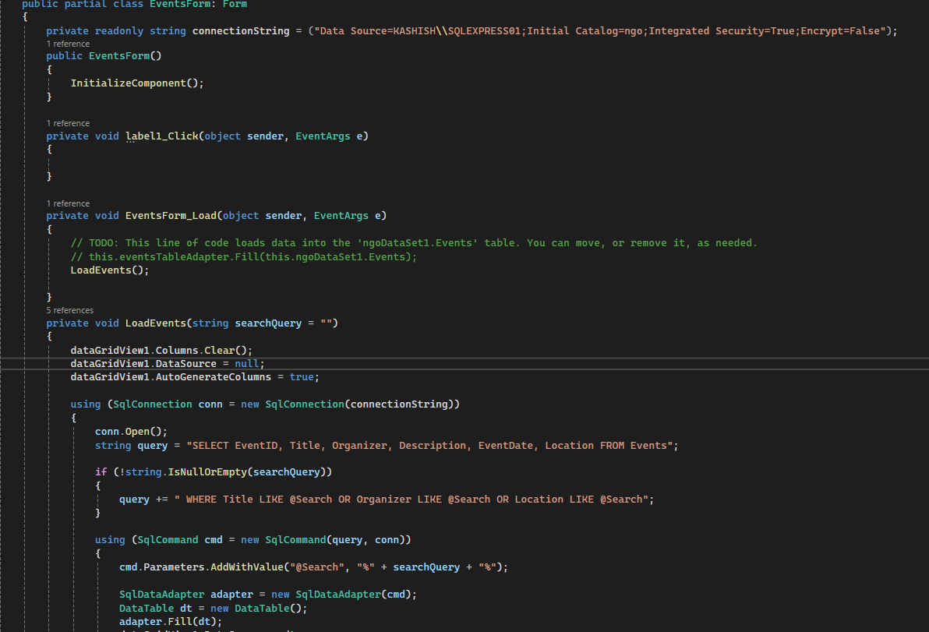

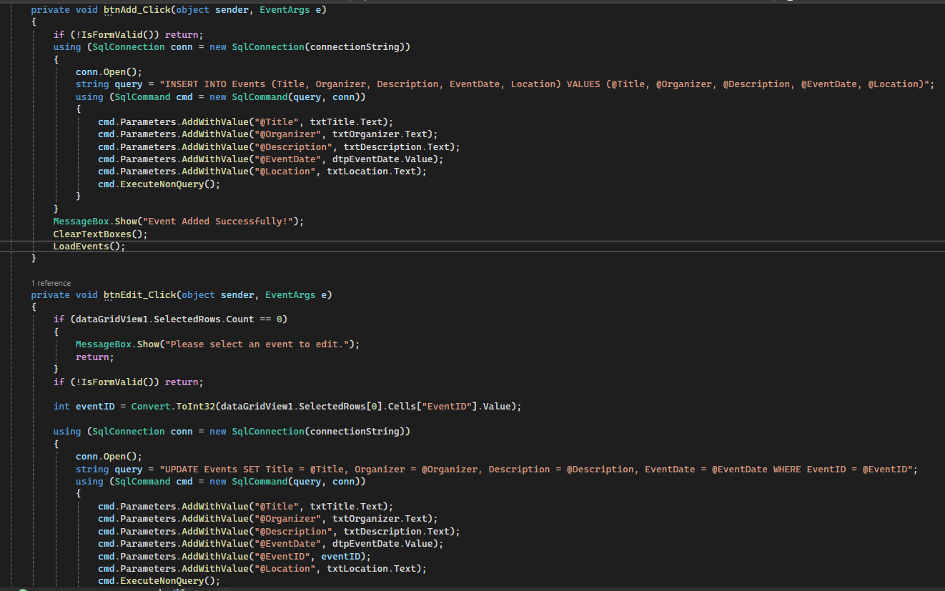

CODE OF DONATION PAGE:

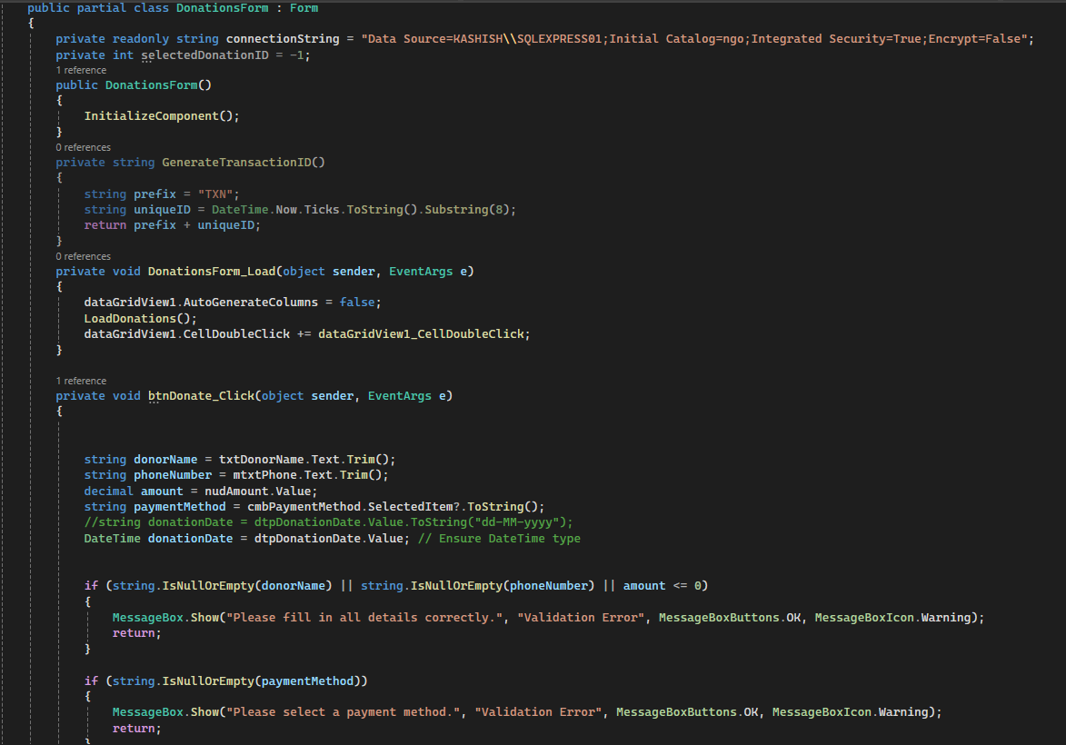

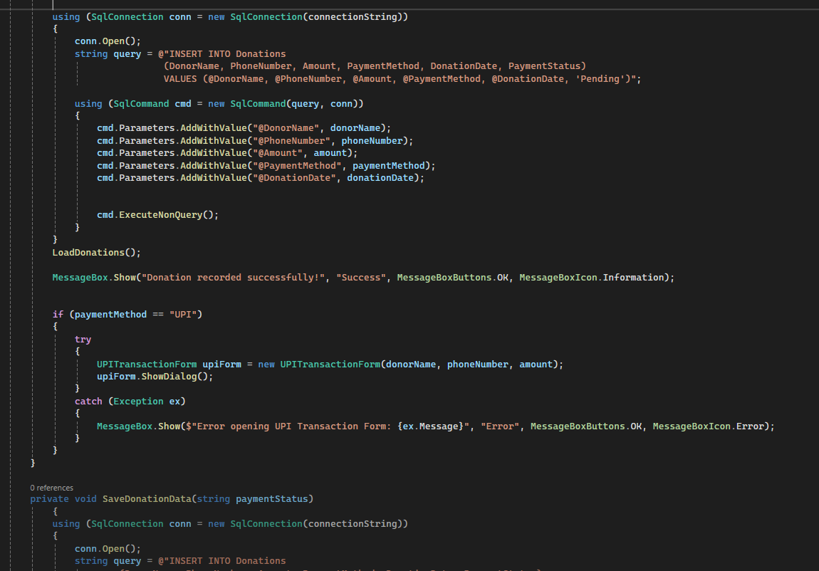

CODE OF UPI TRANSACTION PAGE:

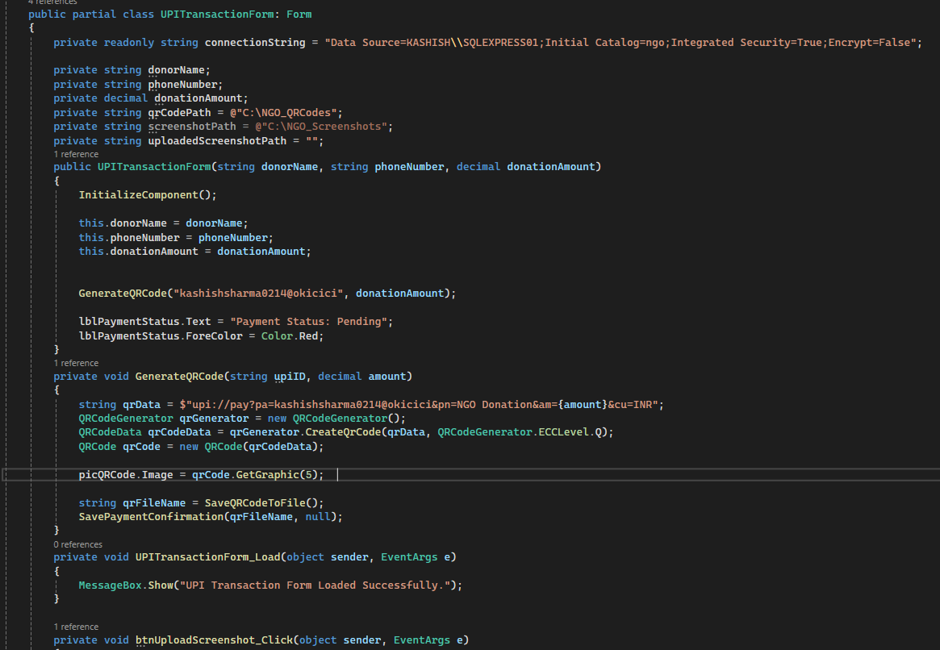

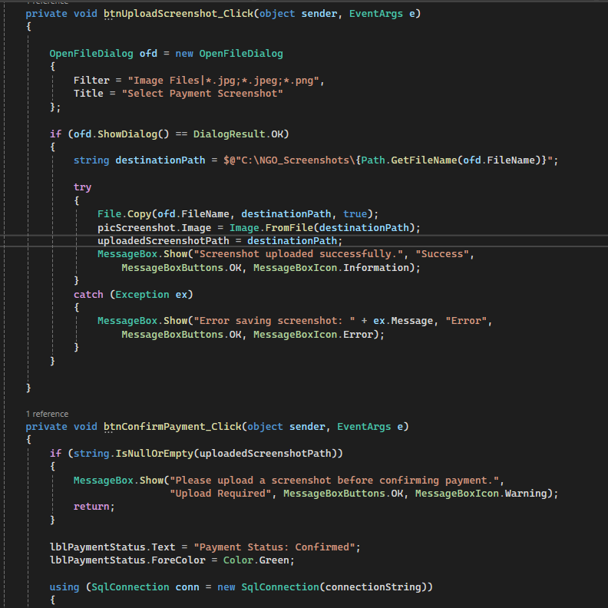

**User Authentication Module:**

Algorithm:

The user enters a username and password on the login page.

* The system checks if the username exists in the database.

If the username does not exist, show an error message: "User not found."

If the username exists, retrieve the stored password from the database.

* Compare the entered password with the stored password.

If the passwords match, grant access to the NGO dashboard.

If the passwords do not match, show an error message: "Incorrect password."

If login is successful, log the user activity and redirect to the dashboard.

* If login fails multiple times, implement account lockout or captcha verification for security.

Flowchart:

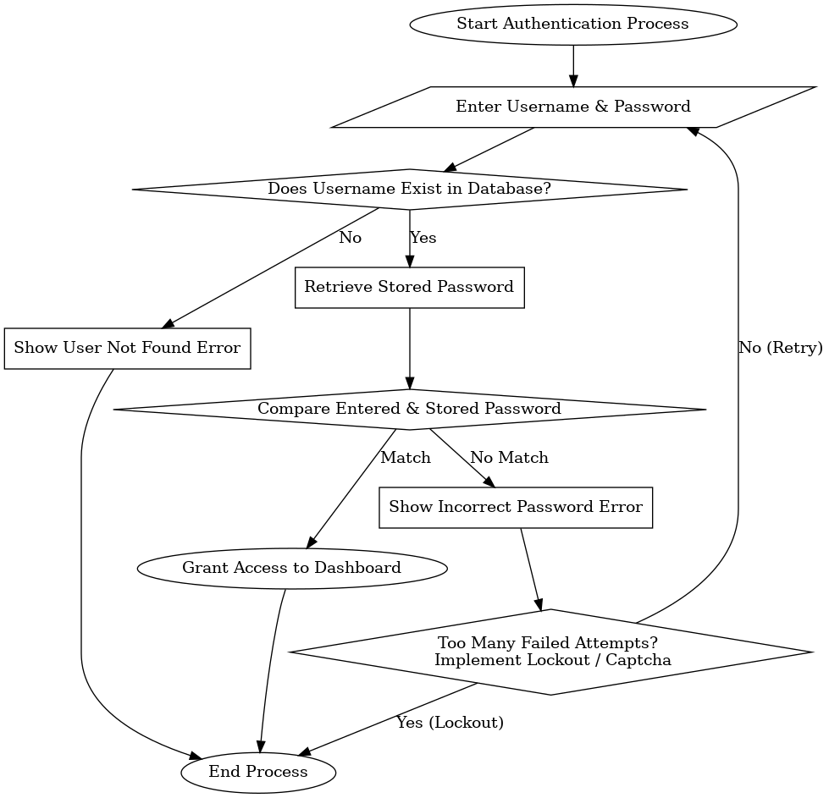

## Testing Approaches

* + 1. Usability Testing

Evaluate the system’s UI/UX for ease of use.

Test navigation flow, clarity of labels, and responsiveness.

Ensure that volunteers, donors, and administrators can easily access and use the platform.

2. Compatibility Testing

Verify that the system works across various devices (PC, tablets, mobile).

Test on different operating systems (Windows, macOS, Android).

Ensure proper rendering in different screen sizes and resolutions.

3. Performance Testing

Test system performance under heavy load (multiple users accessing at once).

Measure response time for database queries, login, donation processing, etc.

Identify bottlenecks that could slow down operations.

4. Security Testing

Ensure user authentication (secure login, password encryption).

Protect donor details and financial transactions.

Check for SQL injection, XSS, and CSRF vulnerabilities.

Test role-based access control (Admins, Volunteers, Donors).

5. Integration Testing

Test seamless integration with external APIs (Payment Gateway for donations).

Verify proper data exchange between different modules (e.g., donation records updating NGO reports).

* 1. **Test cases with test results:**
     1. Usability Testing: Donation Process

Test Case: Fill in donor details and make a donation.

Test Result: Donation is successfully recorded, and a confirmation message is displayed.

Test Case: Cancel a donation before finalizing the payment.

Test Result: Donation is successfully canceled, and no record is saved in the database.

2. Compatibility Testing: Device Compatibility

Test Case: Access the system using different web browsers (Chrome, Firefox, Edge).

Test Result: System functions properly on all tested browsers without layout or functionality issues.

Test Case: Access the system on different devices (desktop, tablet, mobile).

Test Result: System adapts responsively to different screen sizes without loss of functionality.

3. Performance Testing: Response Time

Test Case: Simulate multiple users making donations simultaneously.

Test Result: System response time remains within acceptable limits, and all transactions are processed correctly.

Test Case: Retrieve donor and event records from the database.

Test Result: Records are fetched swiftly, indicating efficient database performance.

4. Security Testing: User Authentication

Test Case: Log in with valid credentials.

Test Result: Successful login, granting access to authorized features based on user role such as Admin, Volunteer, or Donor.

Test Case: Log in with invalid credentials.

Test Result: Login attempt fails with an appropriate error message, preventing unauthorized access.

Test Case: Attempt to access admin-only features as a donor.

Test Result: Access is denied with a proper error message, ensuring role-based security.

# Chapter 6 Results and Discussion

*This chapter presents the Results of testing and discussions.*

As the sole developer of my project, I have conducted a comprehensive suite of tests to ensure the reliability, security, and scalability of the application. The test results are as follows:

1. User Experience Testing Results
   1. Tested Aspect: User Interface and Navigation
   2. Findings:  Users found the interface simple, well-organized, and easy to navigate. The layout, color scheme, and button placements were well received.
   3. Discussion: The user-centric design approach resulted in a user-friendly experience, enhancing engagement and usability.
2. User Registration and Authentication
   1. Tested Aspect: User Account Management
   2. Findings: Users could register and log in without issues. Password validation and error handling functioned correctly.
   3. Discussion: The secure user authentication system provided a hassle-free experience for users, ensuring data privacy and security.
3. Performance and Responsiveness
   1. Tested Aspect: System Performance Under Load
   2. Findings: The system handled multiple concurrent users effectively without significant slowdowns. Pages loaded within acceptable response times.
   3. Discussion: Backend optimizations, efficient database queries, and proper resource management contributed to system stability, ensuring smooth operation even during peak usage.

**Chapter 7 Conclusion and Future Works**

*This chapter presents the conclusion of our documentation and project stating the key achievements and future scopes.*

* 1. **Conclusion**

The NGO Management System is a comprehensive software solution designed to streamline the operations of non-governmental organizations by efficiently managing donations, events, volunteers, and user authentication. The project provides a user-friendly interface that enables donors, volunteers, and administrators to interact seamlessly with the system.

One of the key features of the system is the donation management module, which allows users to make contributions securely while maintaining transaction records. The event and volunteer management module helps NGOs organize events and track volunteer participation, ensuring smooth coordination and effective communication. The user authentication system ensures data privacy and security by implementing role-based access control, preventing unauthorized access to sensitive information.

The system has been tested for usability, security, compatibility, and performance, demonstrating its ability to handle multiple users, process transactions securely, and provide a smooth user experience. The integration of database management ensures the integrity and accuracy of stored data, enabling efficient record-keeping and reporting.

Overall, the NGO Management System enhances the efficiency of NGO operations by reducing manual efforts, minimizing errors, and improving accessibility for all stakeholders. By automating critical processes, the system supports NGOs in achieving their mission more effectively, allowing them to focus on their core objectives—helping communities and making a meaningful impact.

**Future Works**

* Integration of Advanced Technologies: Explore the use of AI and machine learning to enhance the NGO Management System. Features such as automated donation recommendations, predictive analytics for event participation, and chatbot support for volunteers and donors can improve overall efficiency.
* Payment Gateway Expansion: Implement additional payment gateways to provide users with more donation options, including international payment support and cryptocurrency-based donations for global reach.
* Mobile Application Development: Develop a mobile version of the NGO Management System to provide better accessibility for donors and volunteers, allowing them to contribute and participate in events conveniently from their smartphones.
* Volunteer Tracking and Engagement: Introduce a volunteer tracking system that logs hours, assigns roles, and rewards active volunteers through a point-based system or digital certification.
* Social Media and Marketing Integration: Enable seamless integration with social media platforms to promote fundraising campaigns, share event updates, and enhance the visibility of the NGO’s activities.
* Enhanced Security Measures: Strengthen security protocols by integrating two-factor authentication (2FA) and biometric authentication to further protect user accounts and sensitive donor information.
* Automated Reports and Insights: Develop advanced reporting tools that generate automated insights on donation trends, event success rates, and volunteer participation, helping NGOs make data-driven decisions for future initiatives.

# REFERENCES

* Sommerville, I. (2015). Software Engineering (10th ed.). Pearson Education.
* Pressman, R. S., & Maxim, B. R. (2019). Software Engineering: A Practitioner’s Approach (9th ed.). McGraw-Hill.
* Gamma, E., Helm, R., Johnson, R., & Vlissides, J. (1994). Design Patterns: Elements of Reusable Object-Oriented Software. Addison-Wesley.
* IEEE Standard for Software Test Documentation (IEEE Std 829-2008). Institute of Electrical and Electronics Engineers.
* OWASP Foundation. (2024). OWASP Top Ten Security Risks. Retrieved from https://owasp.org/www-project-top-ten/
* Patel, D., & Sharma, K. (2021). "Role of Technology in Enhancing NGO Operations: A Case Study on Digital Management Systems." International Journal of Information Technology & Management Science, 12(3), 45-58.
* Microsoft Documentation. (2024). C# and .NET Framework Development Guide. Retrieved from https://learn.microsoft.com/en-us/dotnet/